|  |  |
| --- | --- |
| **Test Name** | Crown & Anchor Automated Test Fix of Bug 3 |
| **Use Case Tested:** | Automate the testing of errors in UAT Test 3 (for Fix of Bug 3) |
| **Test Description:** | Test that odds in the game are incorrect (win:win+lose ratio should be approximately 4.2) |
| **Pre-conditions** | Single player ‘Anna’ created  Game limit is set = 0  Each run to use a single dice value ‘CROWN’ as the player’s pick.  Game will play 200 turns to ensure there are enough rolls to be statistically significant.  Player will be given a starting balance of $1,000 to ensure they do not run out of funds (i.e. reach the limit) before the end of the 200 turns.  One game will be played with 1000 turns and a starting balance of $10,000 to determine the ratio after a large number of turns.  One game will be played with 50,000 turns and a starting balance of $1,000,000 to determine the ratio after a very large number of turns – this will show if the ratio “settles” down to a single figure. |
| **Post-conditions** | n/a |
| **Notes:** | **An assert will be true if the win:(win+loss) ratio is NOT within the range 4.2 +/- 0.1, i.e. between 41% and 43%.** |
| **Result (Pass/Fail/Warning/Incomplete)** | **1) 200 turns were played and the overall win ratio is 0.5.**  **2) 200 turns were played and the overall win ratio is 0.42.**  **3) 200 turns were played and the overall win ratio is 0.53.**  **4) 10 games played in succession to find range of ratio values (no screenshots for these provided) with results = 38.5, 45.0, 42.5, 43.0, 40.0, 36.0, 39.0, 47.0, 43.0, 36.5. These scores average to 41.05, which is within the range of +/- 1%.**  **5) 1,000 turns were played with a starting balance of $10,000: pass with an overall win ratio of 0.42.**  **6) 50,000 turns were played with a starting balance of $1,000,000: pass with an overall win ratio of 0.42.**  **The above results indicate that the bug is fixed.** |

# Screenshots for Results (by number of result)

1) 200 turns played, ratio = 0.495 (50%):

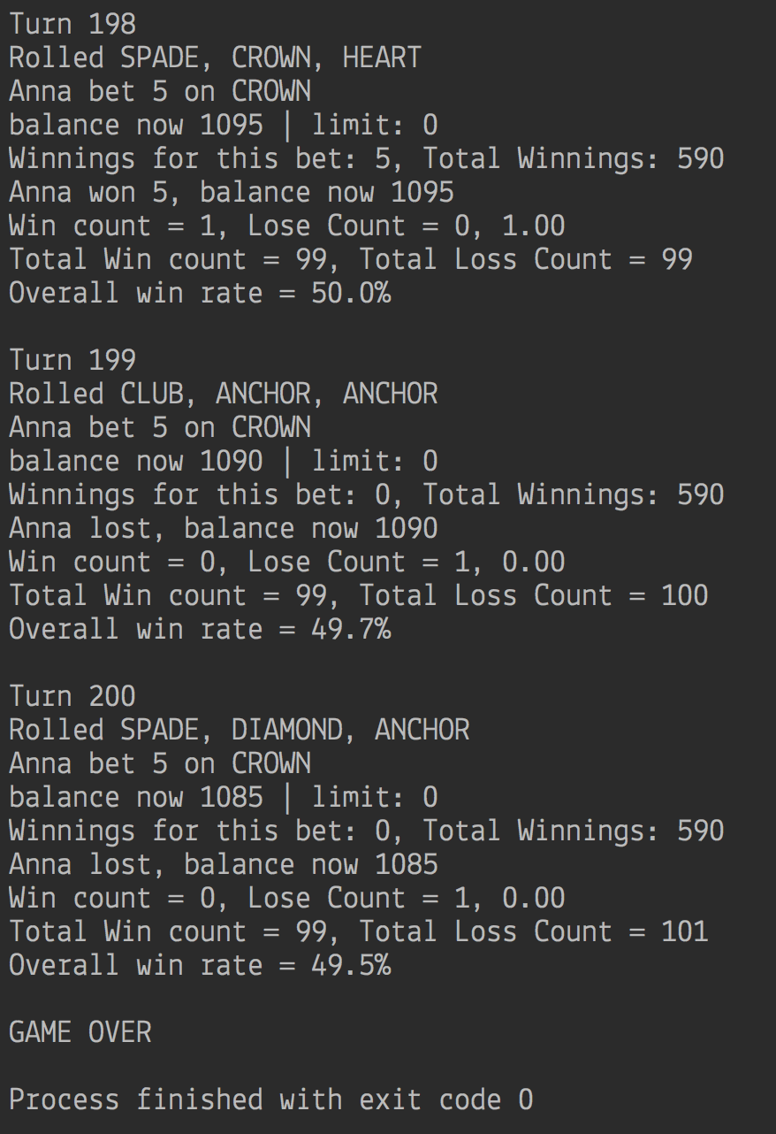

2) 200 turns played, ratio = 0.415 (42%):

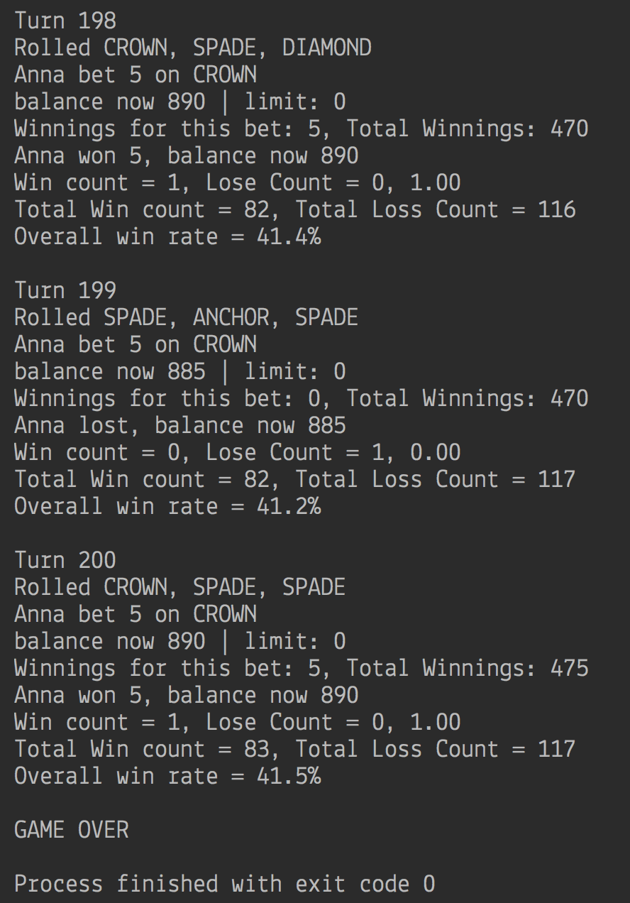

3) 200 turns played, ratio = 0.43 (43%):

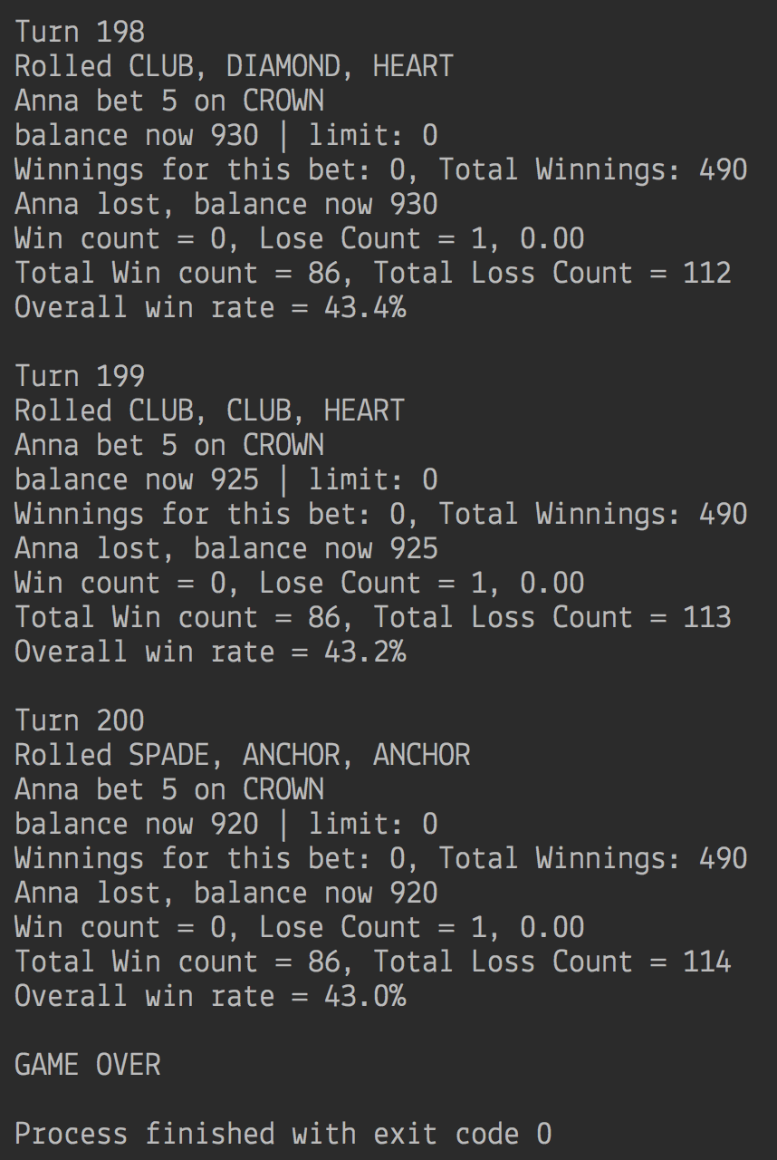

5) 1000 turns played, ratio = 0.417 (42%):

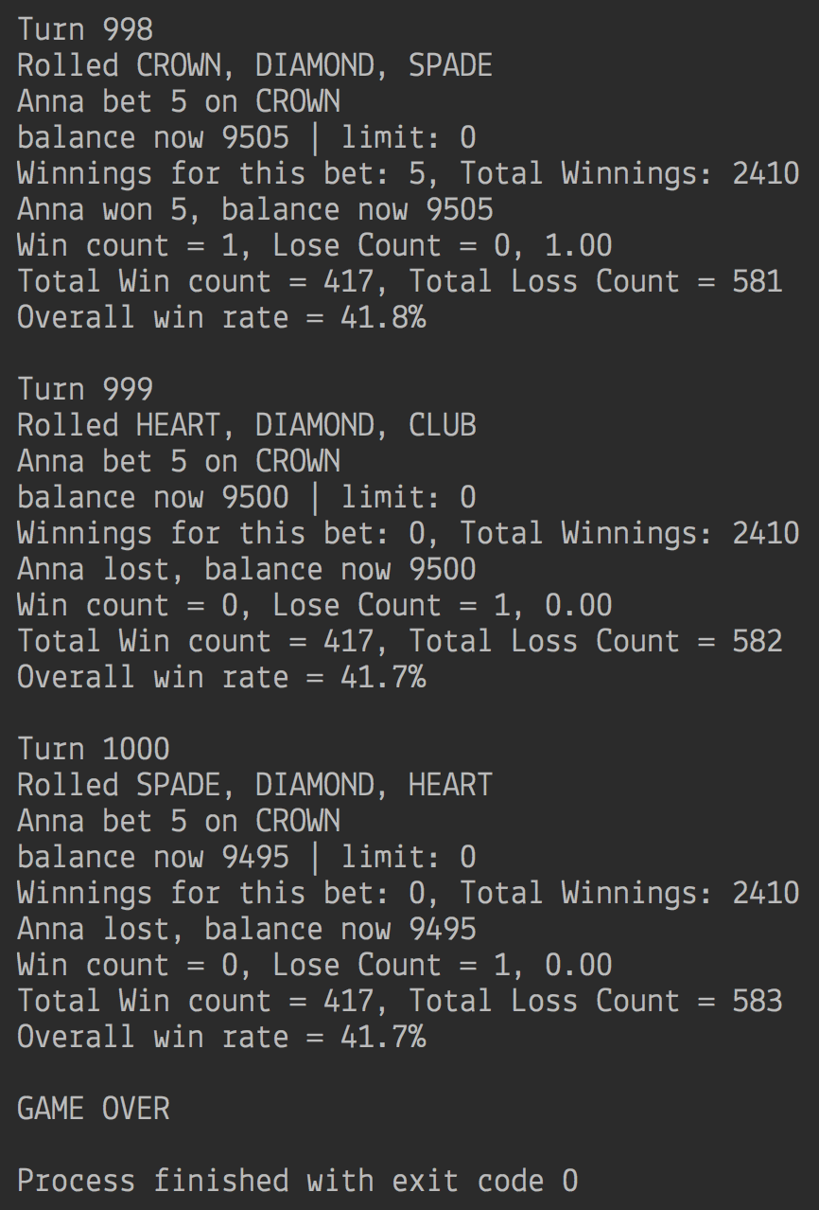

6) 50,000 turns played, ratio = (42%):

